FINAL PAPER DUE ON TURNITIN.COM

- GO TO: www.RhodesEnglishClass.Weebly.com
- Click on: Turnitin.com on the home page: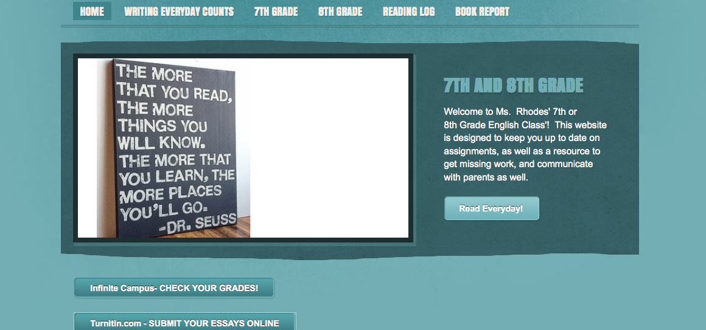
- Then Create an account
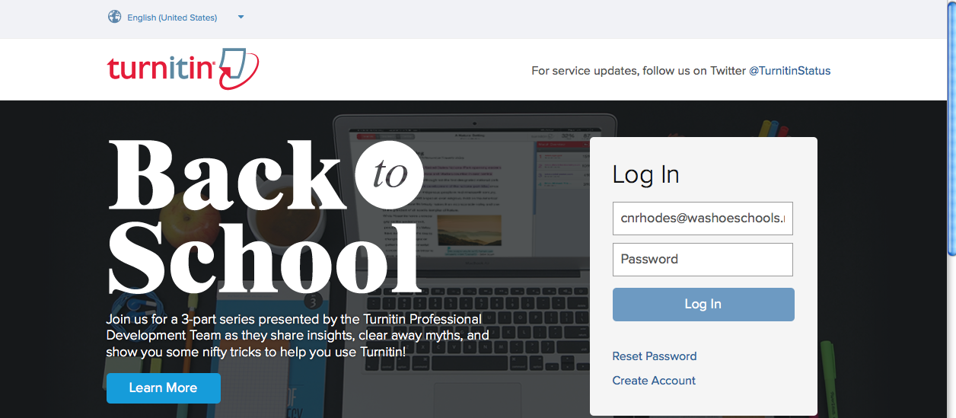
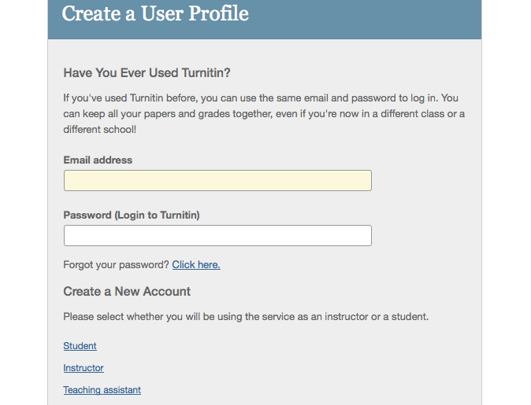
- CLICK STUDENT AT THE BOTTOM IN BLUE
- PUT THE CLASS CODE IN:
1ST- 8810773
2ND- 8810790
4TH- 8810795
5TH- 8810806
6TH- 8810808

Password: Rhodes

- You will then need to write down the login and password you created. Then click on the correct period that appears to submit the paper.
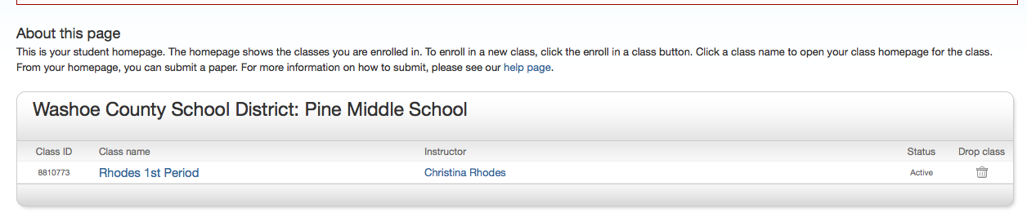
- Click on SUBMIT
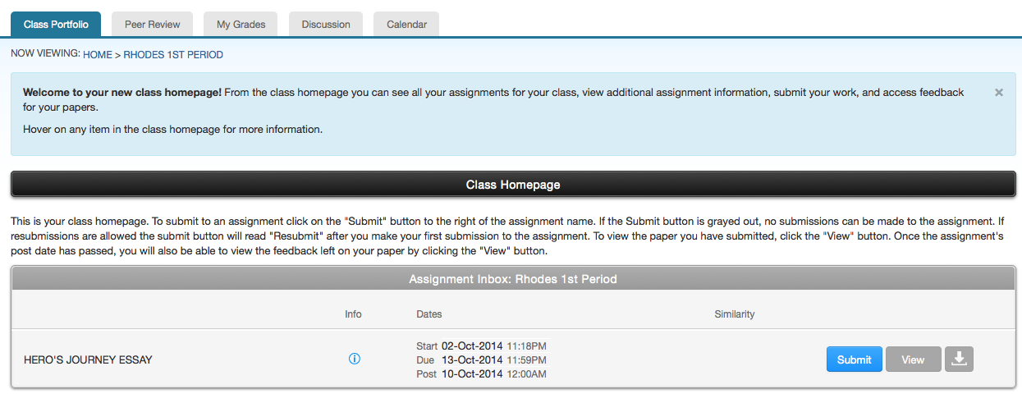
- Attach the paper: ( your name will be in the name box here- not mine) UPLOAD it at the bottom.
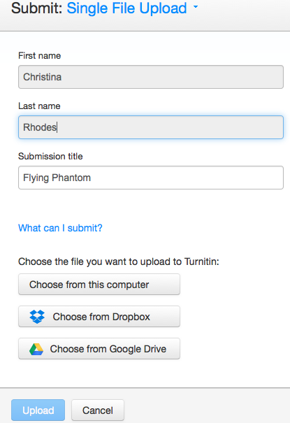

9. Review your paper and press CONFIRM AT THE BOTTOM
.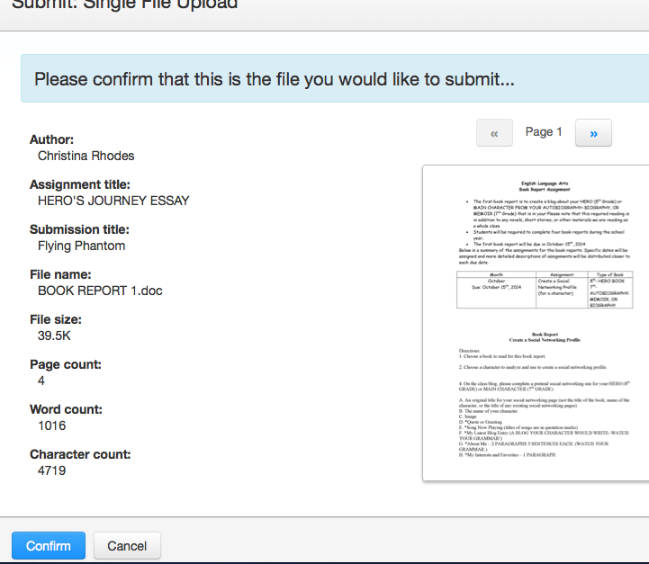
- Make sure you hit confirm and this is what you will see:
